

KSK COLLEGE OF ENGINEERING AND TECHNOLOGY
DEPARTMENT OF COMPUTER SCIENCE AND ENGINEERING

OPTIMIZING USER,GROUP,AND ROLE MANAGEMENT WITH ACCESS CONTROL AND WORKFLOW

Team ID : NM2025TMID07768
Team Size : 4

Team Leader : Hemadharshini S.R
Team member : Sri Swetha k.S
Team member : Devisri S
Team member : Varsha R

Problem statement:
In a small project management team consisting of a Project Manager (Alice) and a Team Member (Bob), there is a need to efficiently manage project tasks and ensure accountability throughout the project lifecycle. The current system lacks clear role definitions, access controls, and a structured workflow, leading to confusion regarding task assignments and progress tracking.

Objective:
- Implement Role-Based Access Control (RBAC) for efficient access management
- Automate user provisioning and deprovisioning processes
- Streamline approval workflows and enhance transparency
- Regularly review and update user access rights and permissions
- Ensure compliance with regulatory requirements and security policies

Skills:
● ServiceNow Catalog Item Creation
● UI Policies & UI Actions
● Update Set Management
● Testing & Deployment
● Team Collaboration

Task initiation:
1. Conduct Current State Assessment: Review existing user, group, and access management processes.
2. Define Requirements and Objectives: Identify business needs and regulatory compliance requirements.
3. Design Target State Architecture: Plan RBAC implementation and workflow automation.
4. Develop Implementation Plan: Create timeline, milestones, and resource allocation plan.
5. Configure and Test Solution: Implement RBAC, automate workflows, and test thoroughly.

Features:
1. Centralized User Management: Single platform for user provisioning, management, and deprovisioning.
2. Role-Based Access Control (RBAC): Assign permissions based on job functions or roles.
3. Attribute-Based Access Control (ABAC): Dynamic access control based on user attributes and environment.
4. Automated Workflows: Streamline approval processes, requests, and escalations.
5. Group Management: Create and manage groups based on departments, roles, or projects.
6. Access Reviews and Audits: Regularly review and update access permissions and roles.
7. Self-Service Portal: Allow users to request access, manage profiles, and reset passwords.
8. Integration with Existing Systems: Integrate with HR systems, directories, apps, and identity providers.
9. Multi-Factor Authentication (MFA): Enhance security with additional authentication factors.
10. Audit Logging and Compliance: Track user activity, access changes, and ensure regulatory compliance.
11. Delegated Administration: Assign administrative tasks to specific users or groups.
12. Customizable Access Policies: Define and enforce access policies based on business needs.

Modules implemented:
The modules implemented for optimizing user, group, management with access control and workflow include User Management, Group Management, and Role-Based Access Control (RBAC). The Access Control module ensures secure access to resources, while the Workflow Management module streamlines business processes. The Audit and Compliance module tracks user activity and ensures regulatory compliance. Additionally, the Self-Service Portal module empowers users to manage their profiles and request access. Integration with existing systems is facilitated through the Integration module. The Authentication module enables Single Sign-On (SSO) and Multi-Factor Authentication (MFA). The Authorization module manages permissions and access rights. Other modules include User Provisioning, Access Review, and Workflow Automation. These modules work together to optimize user, group, and access management. They enhance security, productivity, and compliance. The modules are designed to be flexible and scalable. They can be customized to meet specific business needs. The implementation of these modules has improved overall efficiency.
1.user creation:
1. Open service now
2.Click on All >> search for users
3.Select Users under system security
4.Click on new
5.Fill the following details to create a new user
6.Click on submit
Create one more user:
7.Create another user with the following details
8.Click on submit
2.group creation:
1. Open service now.
2.Click on All >> search for groups
3.Select groups under system security
4.Click on new
5.Fill the following details to create a new group
6.Click on submit
3. Role management:
1.Open service now
2.Click on All >> search for roles
3.Select roles under system security
4.Click on new
5.Fill the following details to create a new role
6.Click on submit
4.Assign users to group:
Assign roles to alice user:
1.Open service now.
2.Click on All >> search for roles
3.Select roles under system security
4.Click on new
5.Fill the following details to create a new role
6.Click on submit
Assign roles to bob user:
- Open servicenow.Click on All >> search for user
- Select tables under system definition
- Select the bob p user
- Under team member
- Click on edit
- Select team member and give table role and save
- Click on profile icon Impersonate user to bob
- We can see the task table2.
5.Application access:
Assign table access to application:
- while creating a table it automatically create a application and module for that table
- Go to application navigator search for search project table application
- Click on edit module
- Give project member roles to that application
- Search for task table2 and click on edit application.
- Give the project member and team member role for task table 2 application

6.Access Control List:
Create ACL:
- Open service now.
- Click on All >> search for ACL
- Select Access Control(ACL) under system security
- Click on elevate role
- Click on new
- Fill the following details to create a new ACL

7.Flow:
Create a Flow to Assign operations ticket to group:
- Open service now.
- Click on All >> search for Flow Designer
- Click on Flow Designer under Process Automation.
- After opening Flow Designer Click on new and select Flow.
- Under Flow properties Give Flow Name as “ task table”.
- Application should be Global.
- Click build flow.

Implementation steps:
1.create users:

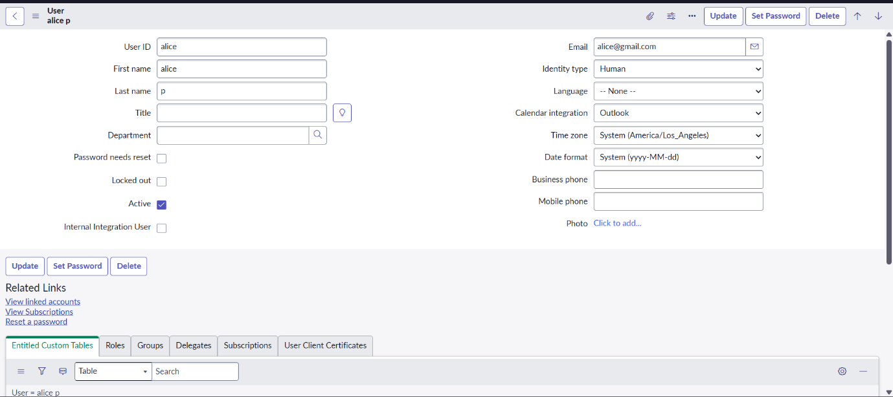

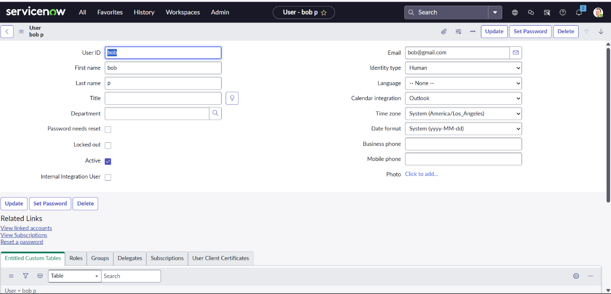
2.create groups:
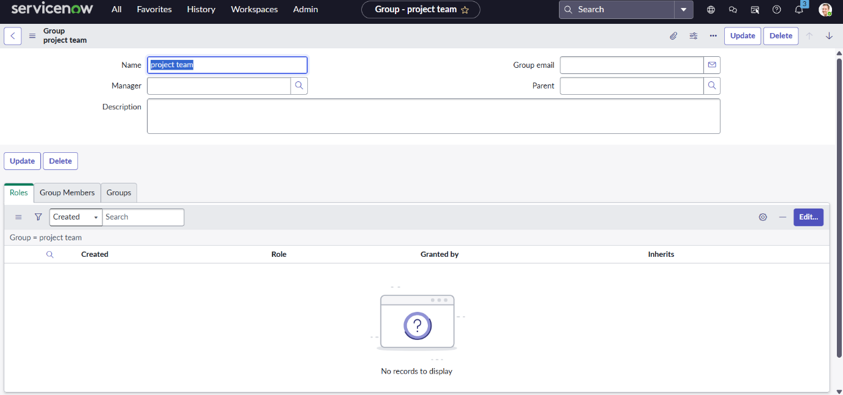
3.create roles:

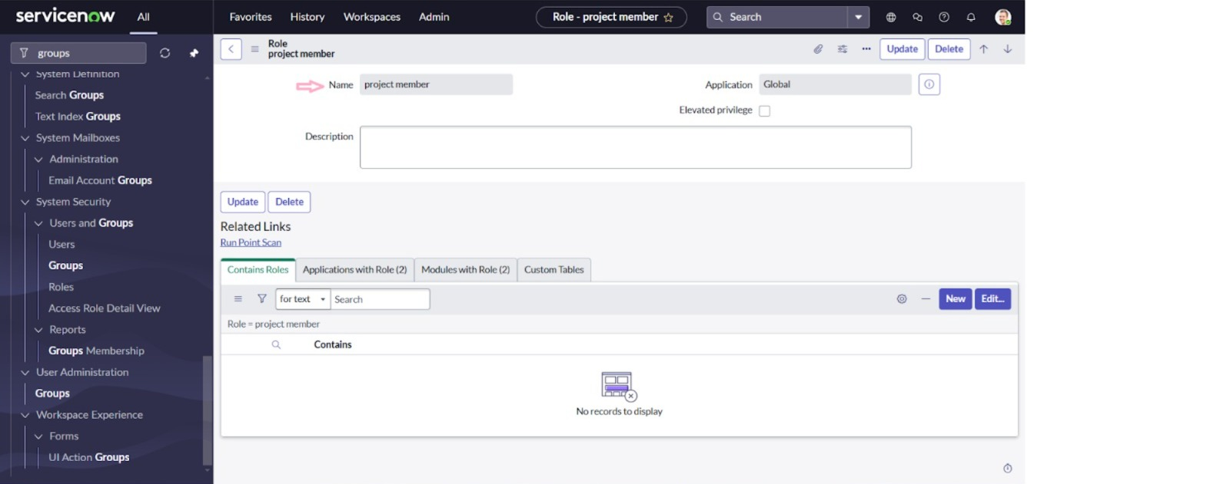

4.Assign users to groups:
Assign role to alice user:

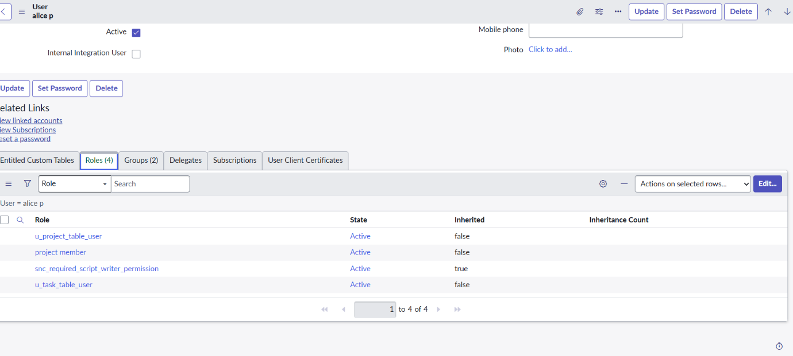

Assign roles to bob user:

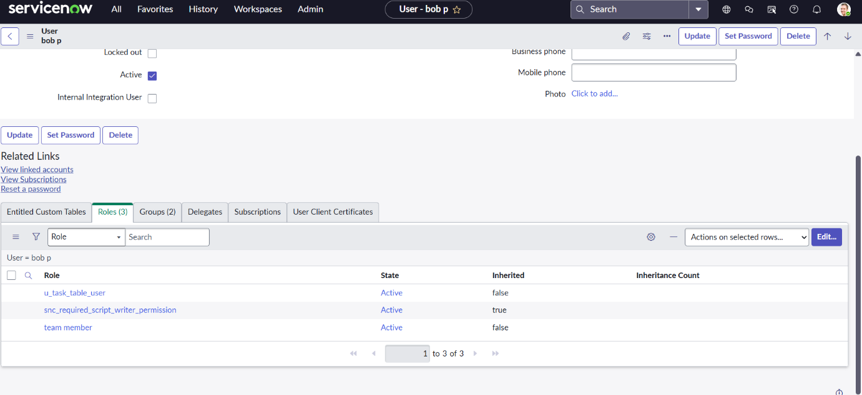

5.Application access:
Assign table access to application:
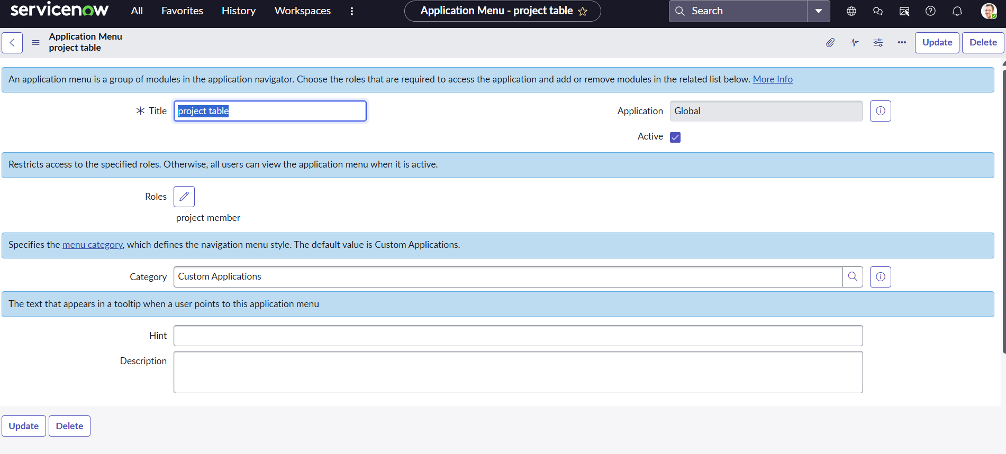

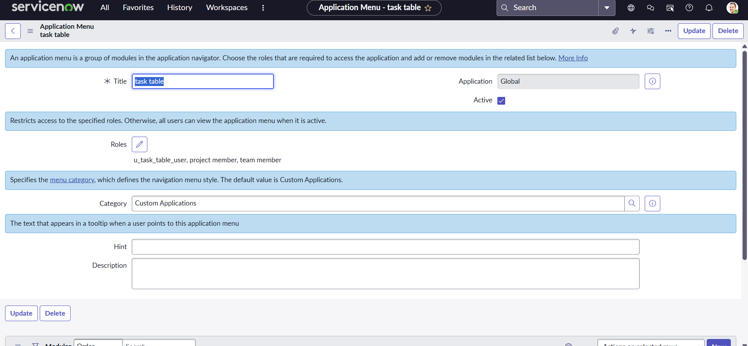

6.Access Control List:
Create ACL:

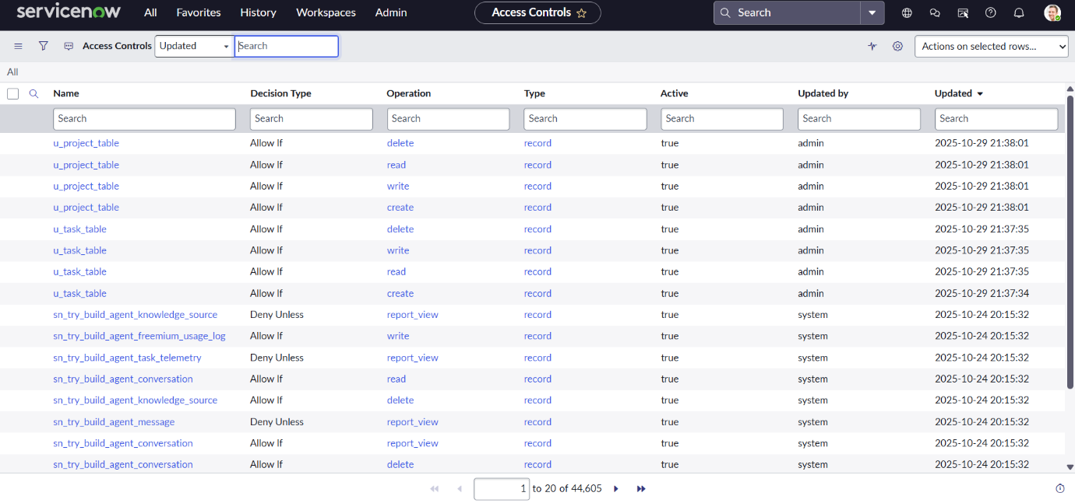

7.Flow:
Create a Flow to Assign operations ticket to group:

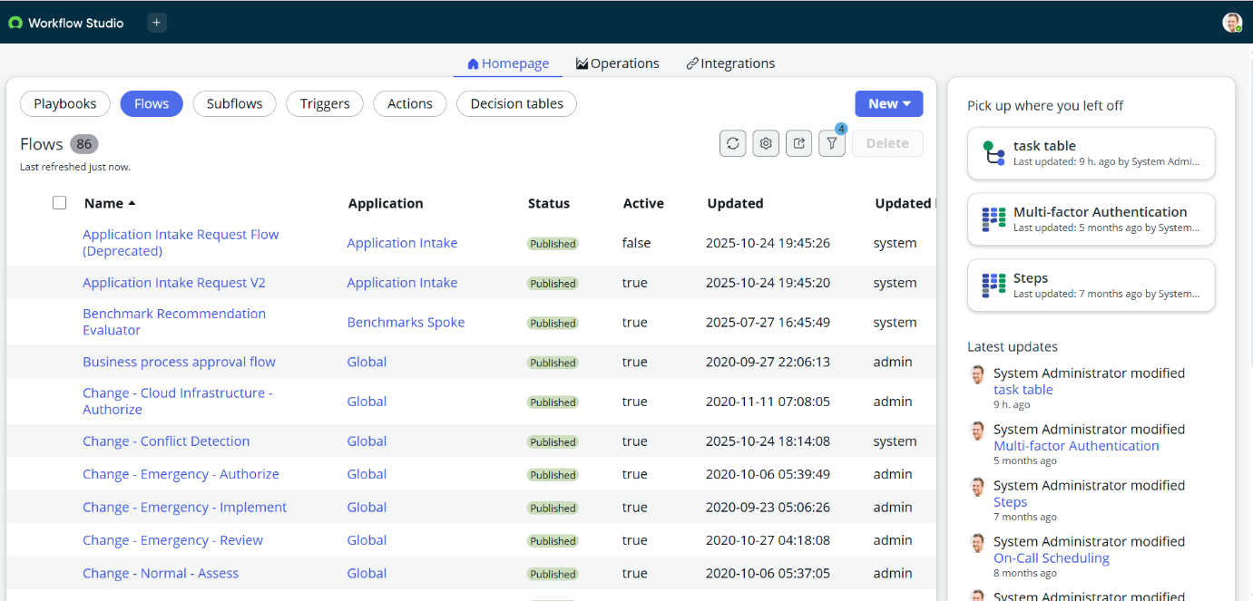

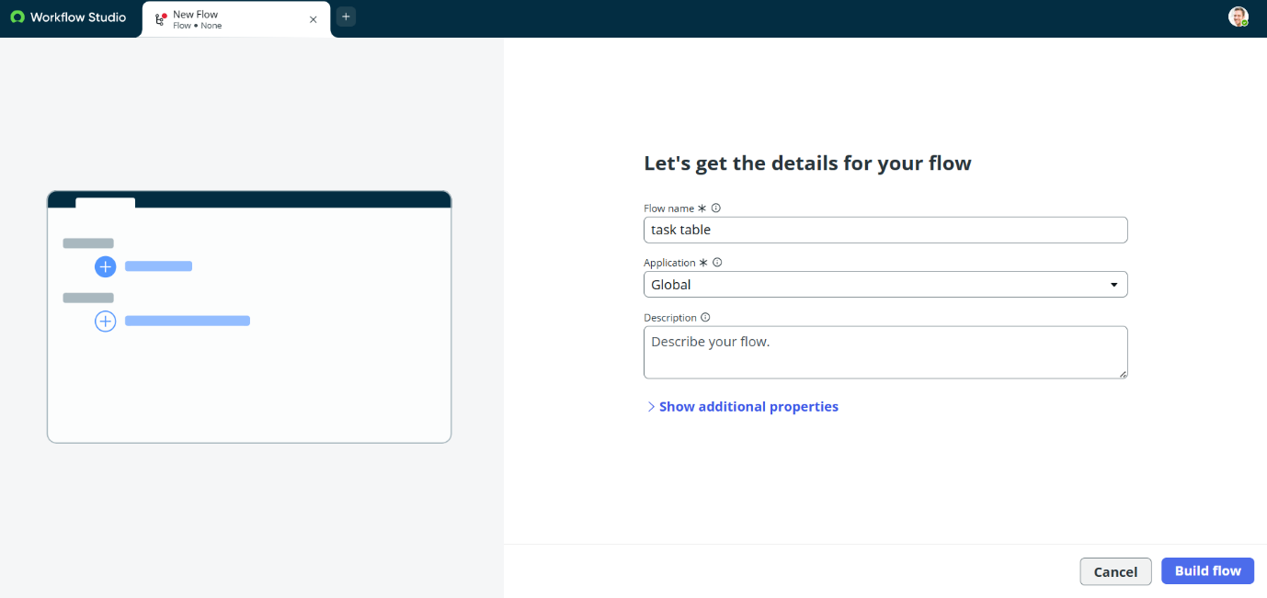

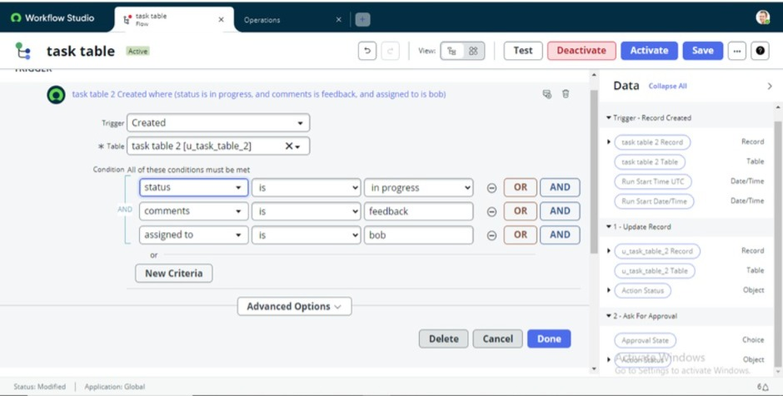

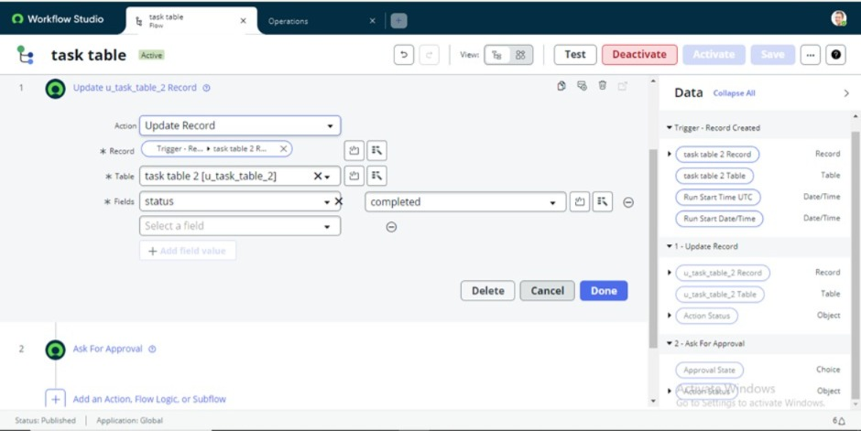
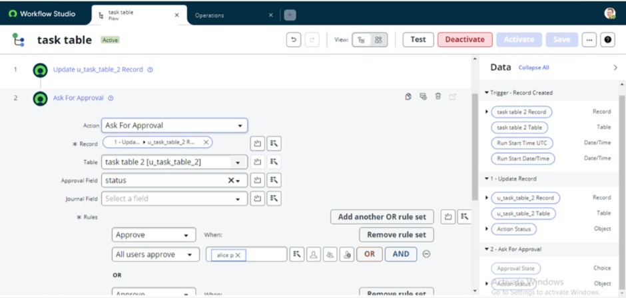

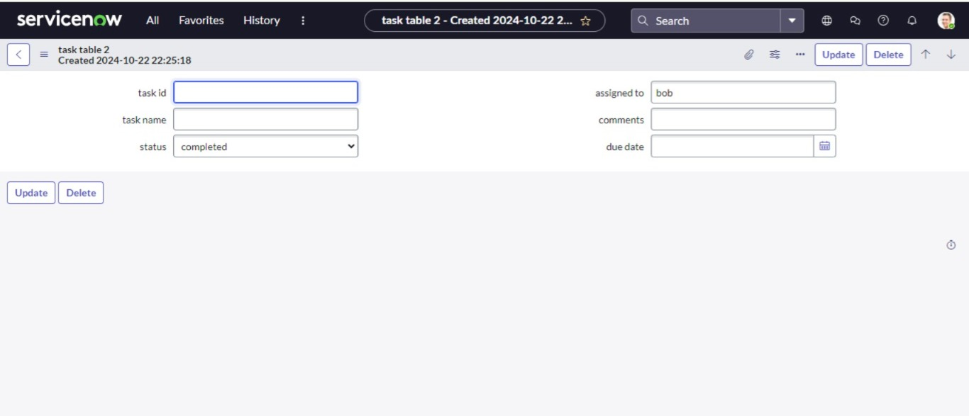
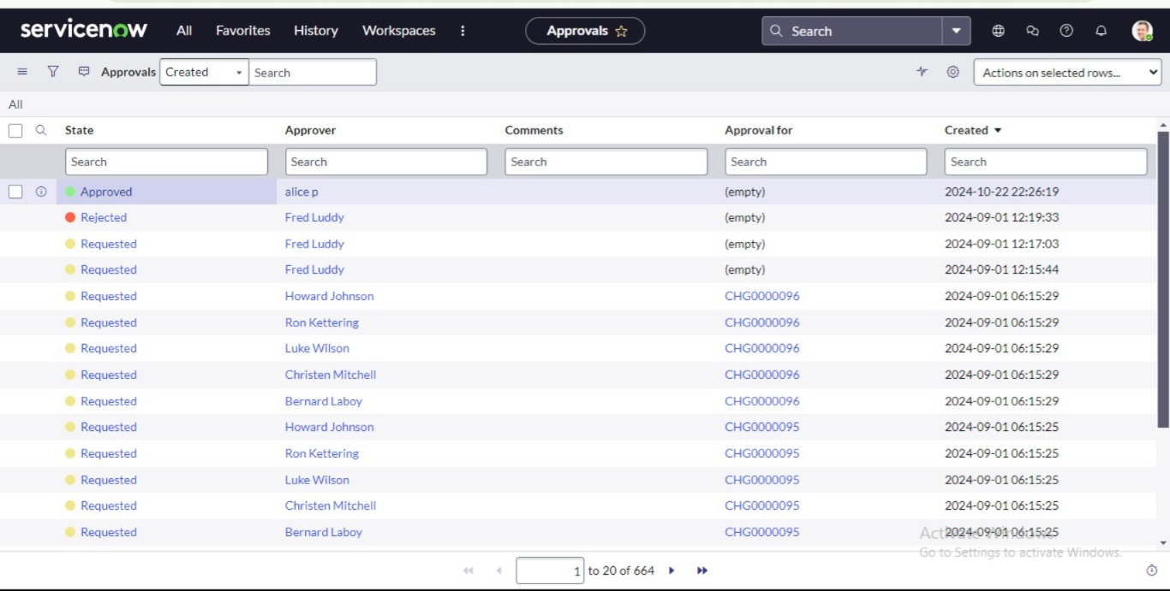

8.Output:

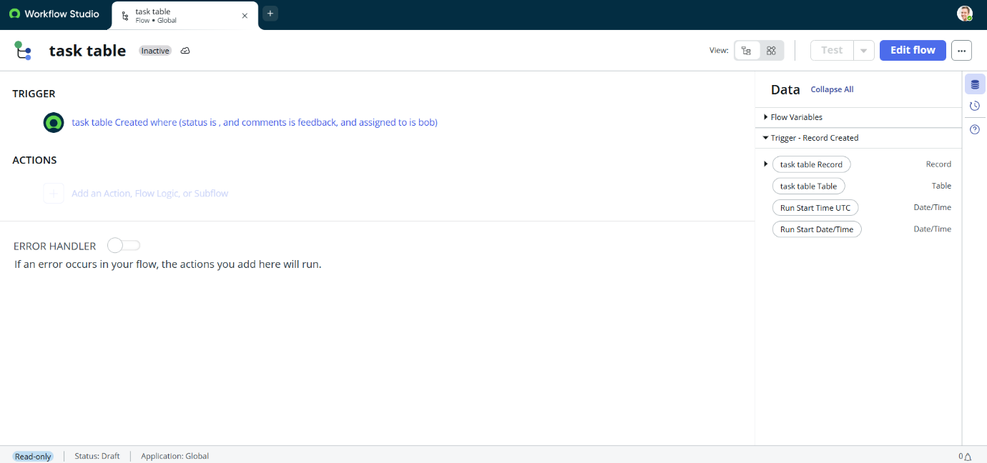

Outcome:
Optimizing user, group, and role management with access control and workflow improves security, efficiency, and compliance. It streamlines processes, reduces risk, and enhances collaboration. Automated workflows increase productivity and reduce manual errors. Access control ensures data integrity and confidentiality. Overall, it leads to better decision-making and improved business outcomes.

Conclusion :
This scenario highlights a structured approach to project management, showcasing the roles of Alice and Bob within a defined workflow. With Alice's oversight and Bob's execution, the team effectively collaborates to ensure project success. The use of tables organizes key information, facilitating easy tracking of projects, tasks, and progress updates. Overall, this system promotes accountability, enhances communication, and leads to the successful completion of projects.

